RPA Proof of Concept

Process Definition Document for Internal Invoicing.

**Revision 1.0**

RESTRICTED DISTRIBUTION

The information is standard Company Confidential but due to its sensitivity it has restricted distribution and viewing within the Capgemini Group.

Document Version Control

|  |  |  |  |
| --- | --- | --- | --- |
| **Date Issued** | **Version** | **Description** | **Author** |
| 7/5/2018 | V0.1 | Draft Version |  |
|  |  |  |  |

Contributors

The content of this document has been authored with the combined input of the following group of key individuals.

|  |  |  |
| --- | --- | --- |
| **Name** | **Role** | **Area** |
|  |  |  |

Source Documents

|  |  |  |  |
| --- | --- | --- | --- |
| **Title** | **Author** | **Version** | **Date** |
| PCR | Anil Khedgikar | V1.1 | 7/5/2018 |
|  |  |  |  |

Document Sign-off Requirements

The following table contains the people required to sign-off and/or review this document and those that require the document for information only.

|  |  |  |
| --- | --- | --- |
| **Name** | **Department** | **Responsibility** |
|  |  | Sign Off |
|  |  | Review |
|  |  | Information |

Document Classification

|  |  |
| --- | --- |
| **Classification** | Company Confidential |
| **Definition** | Information is Group confidential and needs to be protected |
| **Context** | Where loss of information confidentiality would result in significant harm to the interests of the organisation, financial loss, embarrassment or loss of information |

Table of Contents

Introduction 4

Overview 4

Robot Cycle Time 4

Operational Constraints 4

Current Process Details 5

1 Extraction of Reports 5

1.1 Extraction of Revenue Report Event Entry from BI Tool 5

1.2 Extraction of Project Contribution Report 9

1.3 Extraction of Project Revenue Report from BO Tool 12

1.4 Extraction of Revenue Report for Expenses from BI Tool 16

1.5 Extraction of Shift and Oncall Project Revenue Report from BI Tool 19

1.6 Extraction of Project Set-Up Query from BI Tool 22

2 Workings 24

2.1 Workings in the PCR Template 24

2.2 Project Revenue Report 26

2.3 Expenses 28

2.4 Shift On Call 30

2.5 Working of Invoice Tracker 31

## Introduction

The Process Definition Document (PDD) captures the flow of a business process to be developed within CG.

The Project Contribution Report is prepared for the Revenue reconciliation of each project code.

The system revenue is tallied/reconciled with the Revenue reports of Time, Expenses & On call Shift.

Project Revenue Report contains the details of Time revenue

Revenue Report for Expenses contains the details of Expenses.

Shift and Oncall Project Revenue Report contains the details of Shift Allowances.

The purpose of this working is to prepare draft invoices for sending it to Project Managers of respective projects

# Overview

The purpose of this document is to outline the detailed process steps, assumptions and data mapping requirements for the Robotics POC being conducted by GSS Invoicing Team (Finance-ACIS) which commenced on 20th April 2018.

The POC will showcase Robots …

## Robot Cycle Time

TBD

## Operational Constraints

TBD

# Current Process Details

1. Extraction of Reports
   1. Extraction of Revenue Report Event Entry from BI Tool

* Login to BI tool <http://gfsbi4.capgemini.com/BOE/BI>
* Enter Login ID Password
* Go to Documents tab 🡪 Folders 🡪 Public Folders 🡪 GFS Local Report 🡪 India Local Report 🡪PA 🡪 Revenue and invoice details for Event Entry

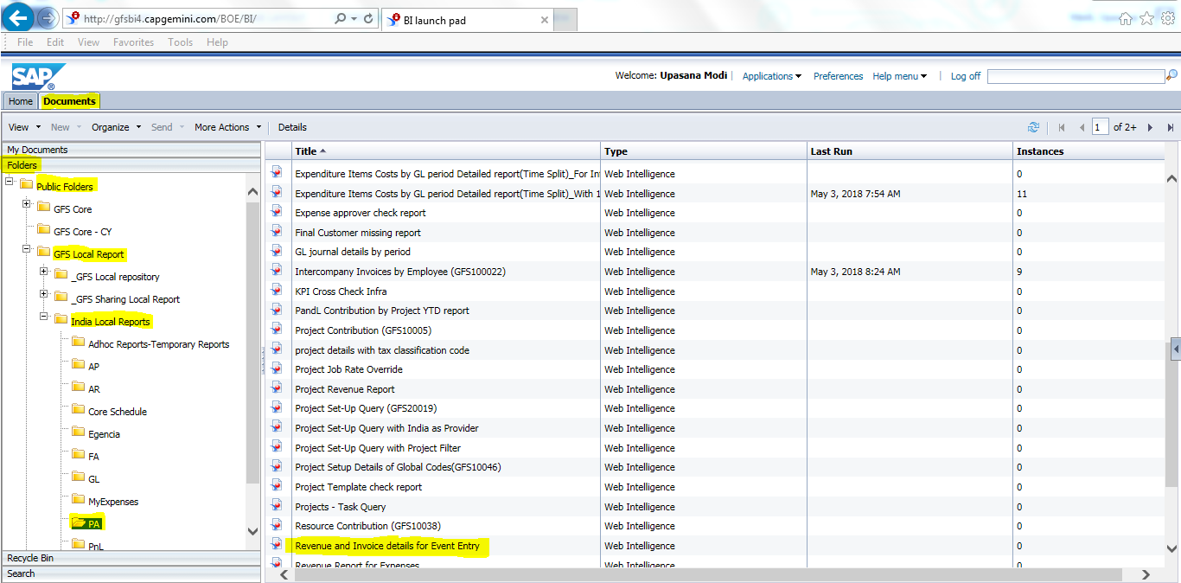

* Click on the Refresh button  as below:-

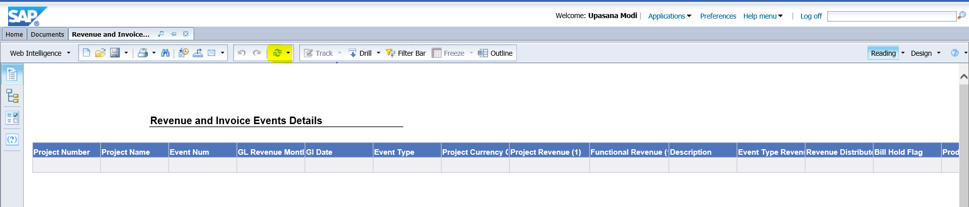

* A dialogue box will appear as below :-

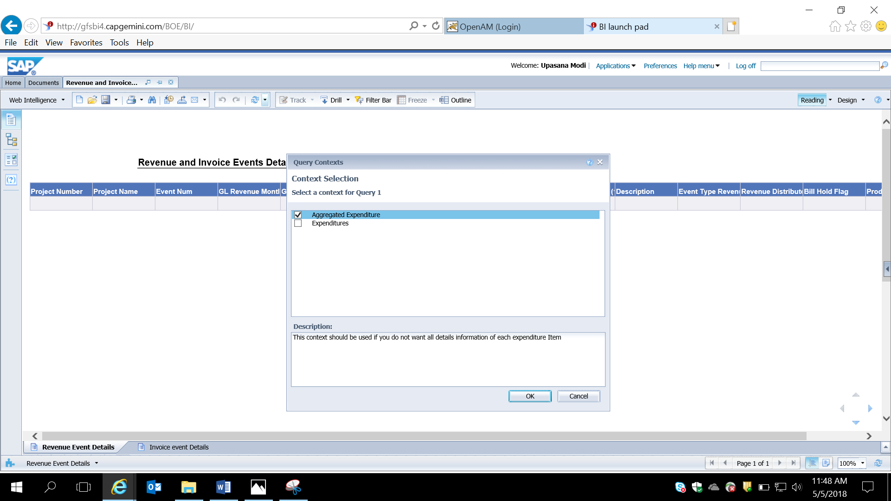

* Select Aggregated Expenditure & Click OK.
* A dialogue box will appear as below:-

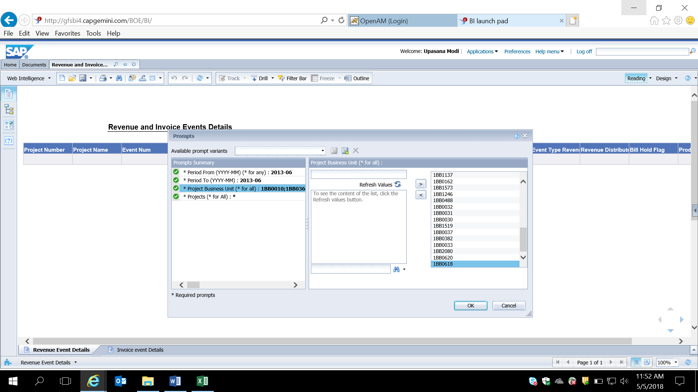

* Go to Period From & Enter the Previous month(E.g. in May’18- enter month April’18)
* Go to Period To & Enter the Previous Month
* Click on Project Business Unit🡪 Go to **file:///\\ntbomfs001\Datagrp\FINANCE%20MODULE\Finance%202018\Global%20Shared%20Services\Invoicing%20Tower\Others\BU%20Code%20List_GSS_2018.xlsx**
* After opening “BU Code List_GSS_2018” go to C52 of formula sheet. Copy and paste the list in BI Tool (Project Business Unit) as per above example. And click on the arrow as shown in the example.

(If there are values in the right most box then double click on it then enter the BU list in the text box and click on side arrow)

* Click OK
* Once the data is retrieved, Click on Export button -  🡪 Go to file type dropdown 🡪 Select Excel(.xlsx) & click OK

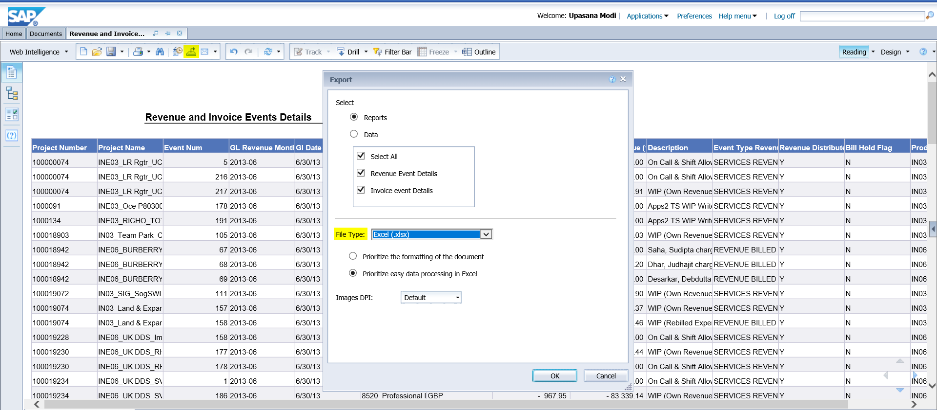

* A dialogue box will appear as below :-



* Click the drop down besides save & select Save as
* Save the file in the respective folder of current months repository
  1. Extraction of Project Contribution Report
* Login to BI tool <http://gfsbi4.capgemini.com/BOE/BI>
* Enter Login ID Password
* Go to Documents tab 🡪 Folders 🡪 Public Folders 🡪 GFS Local Report 🡪 India Local Report 🡪PA 🡪 Project Contribution (GFS10005)

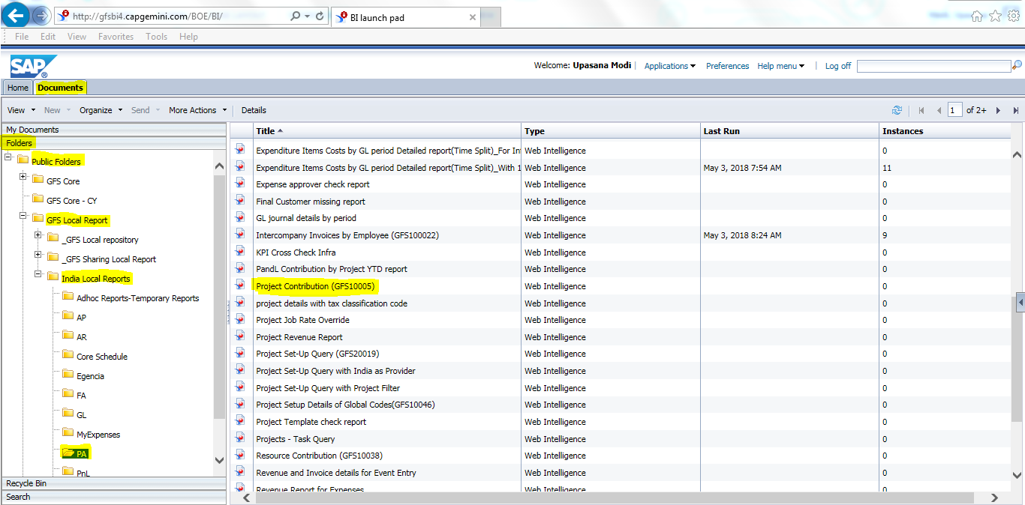

* Click on the Refresh button  as below:-

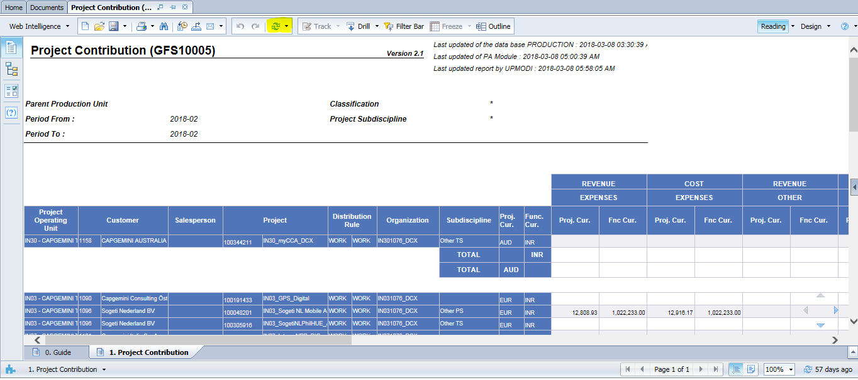

* A dialogue box will appear as below:-

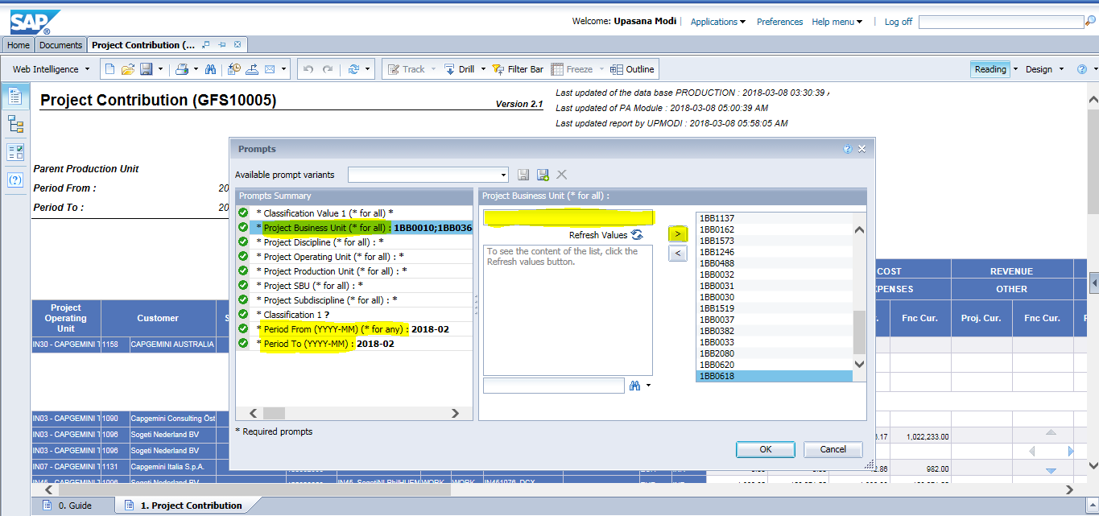

* Click on Project Business Unit🡪 Go to **file:///\\ntbomfs001\Datagrp\FINANCE%20MODULE\Finance%202018\Global%20Shared%20Services\Invoicing%20Tower\Others\BU%20Code%20List_GSS_2018.xlsx**
* After opening “BU Code List_GSS_2018” go to C52 of formula sheet. Copy and paste the list in BI Tool (Project Business Unit) as per above example. And click on the arrow as shown in the example.

(If there are values in the right most box then double click on it then enter the BU list in the text box and click on side arrow)

* Go to Period From & Enter the Previous month
* Go to Period To & Enter the Previous Month
* Click OK
* Once the data is retrieved, Click on Export button -  🡪 Go to file type dropdown 🡪 Select Excel(.xlsx) & click OK

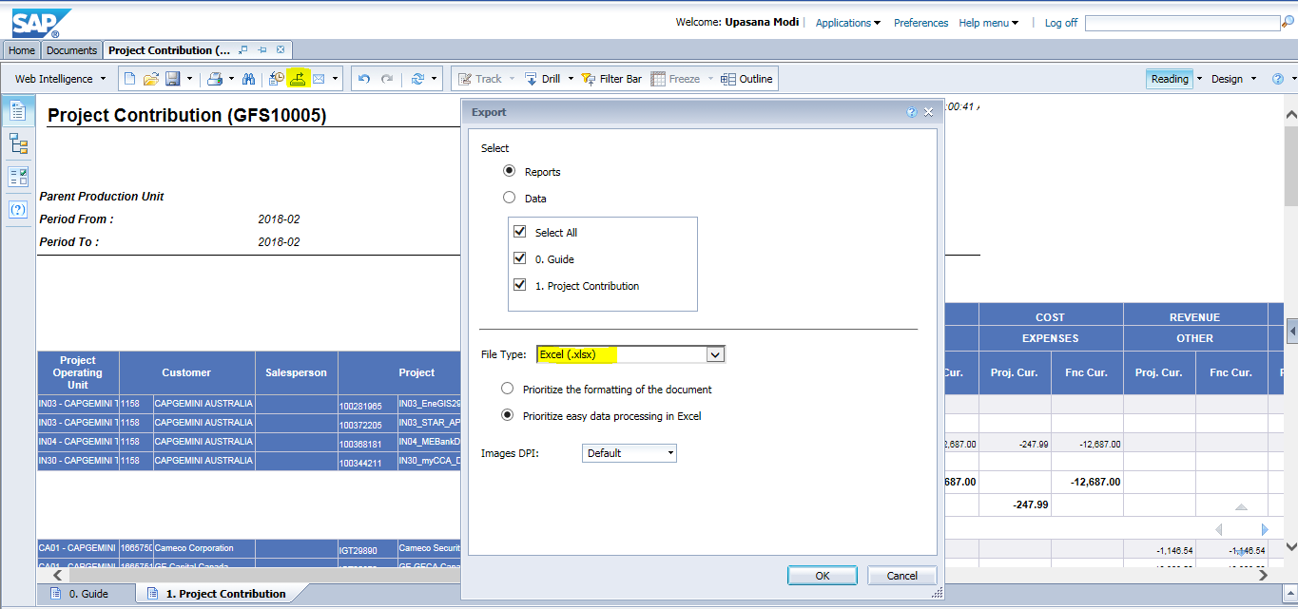

* A dialogue box will appear as below :-



* Click the drop down besides save & select Save as
* Save the file in the respective folder of current months repository
  1. Extraction of Project Revenue Report from BO Tool
* Login to BI tool <http://gfsbi4.capgemini.com/BOE/BI>
* Enter Login ID Password
* Go to Documents tab 🡪 Folders 🡪 Public Folders 🡪 GFS Local Report 🡪 India Local Report 🡪PA 🡪 Project Revenue Report

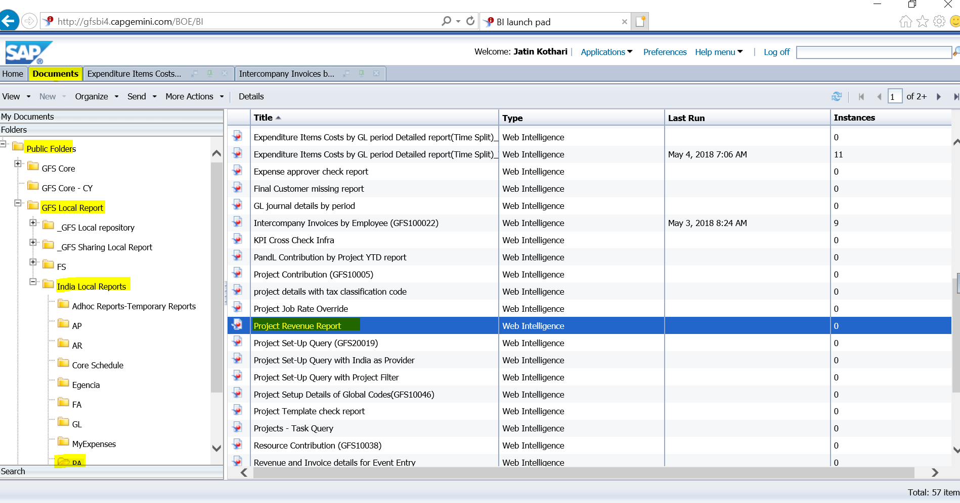

* Click on the Refresh button  as below:-

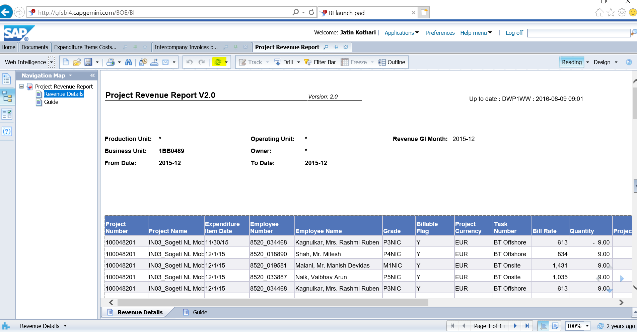:-

* A dialogue box will appear as below:
* **Prompts:**
* **Period From (YYYY-MM)-enter the previous month**
* **Period To (YYYY-MM)-enter the previous month**
* **For Project business unit (*for all)- go to** **file:///\\ntbomfs001\Datagrp\FINANCE%20MODULE\Finance%202018\Global%20Shared%20Services\Invoicing%20Tower\Others\BU%20Code%20List_GSS_2018.xlsx**
* **After opening “BU Code List_GSS_2018” go to C52 of formula sheet. Copy and paste the list as per below example. And click on the arrow as shown in example.**

**(If there are values in the right most box then double click on it then enter the BU list in the text box and click on side arrow)**

* **Revenue GL month- enter the previous month (If there are values in the right most box then double click on it then enter the previous month in the text box and click on side arrow)**

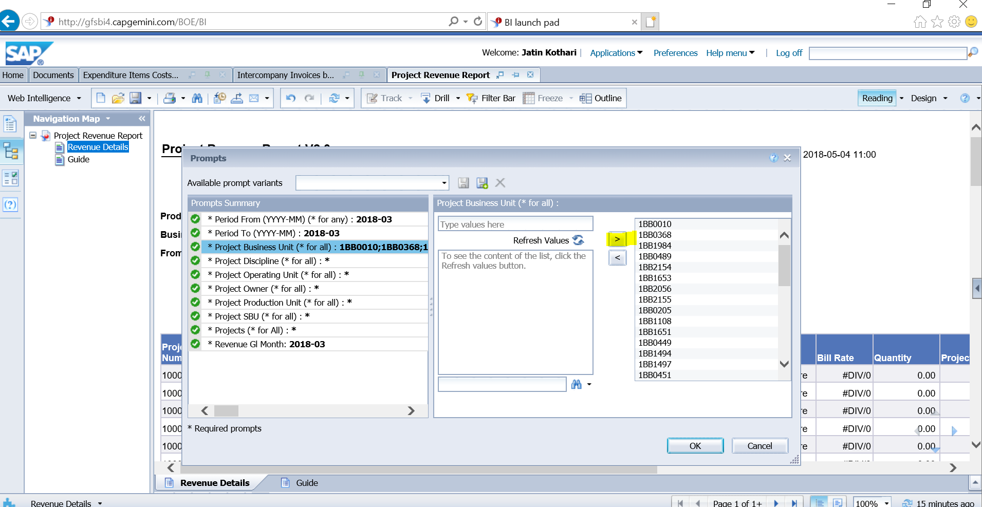

* Click on OK
* Once the data is retrieved, Click on Export button & Go to file type dropdown ànd  Select Excel(.xlsx) & click OK

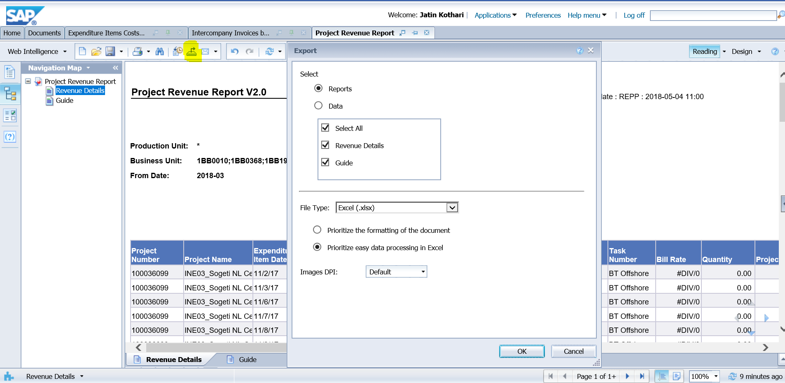

* Another dialogue box will open as below:-



* Click on the arrow next to Save and select Save As.
* Save the file in the respective folder of current month’s repository and start the working.
  1. Extraction of Revenue Report for Expenses from BI Tool
* Login to BI tool <http://gfsbi4.capgemini.com/BOE/BI>
* Enter Login ID Password
* Go to Documents tab 🡪 Folders 🡪 Public Folders 🡪 GFS Local Report 🡪 India Local Report 🡪PA 🡪 Revenue Report for Expenses

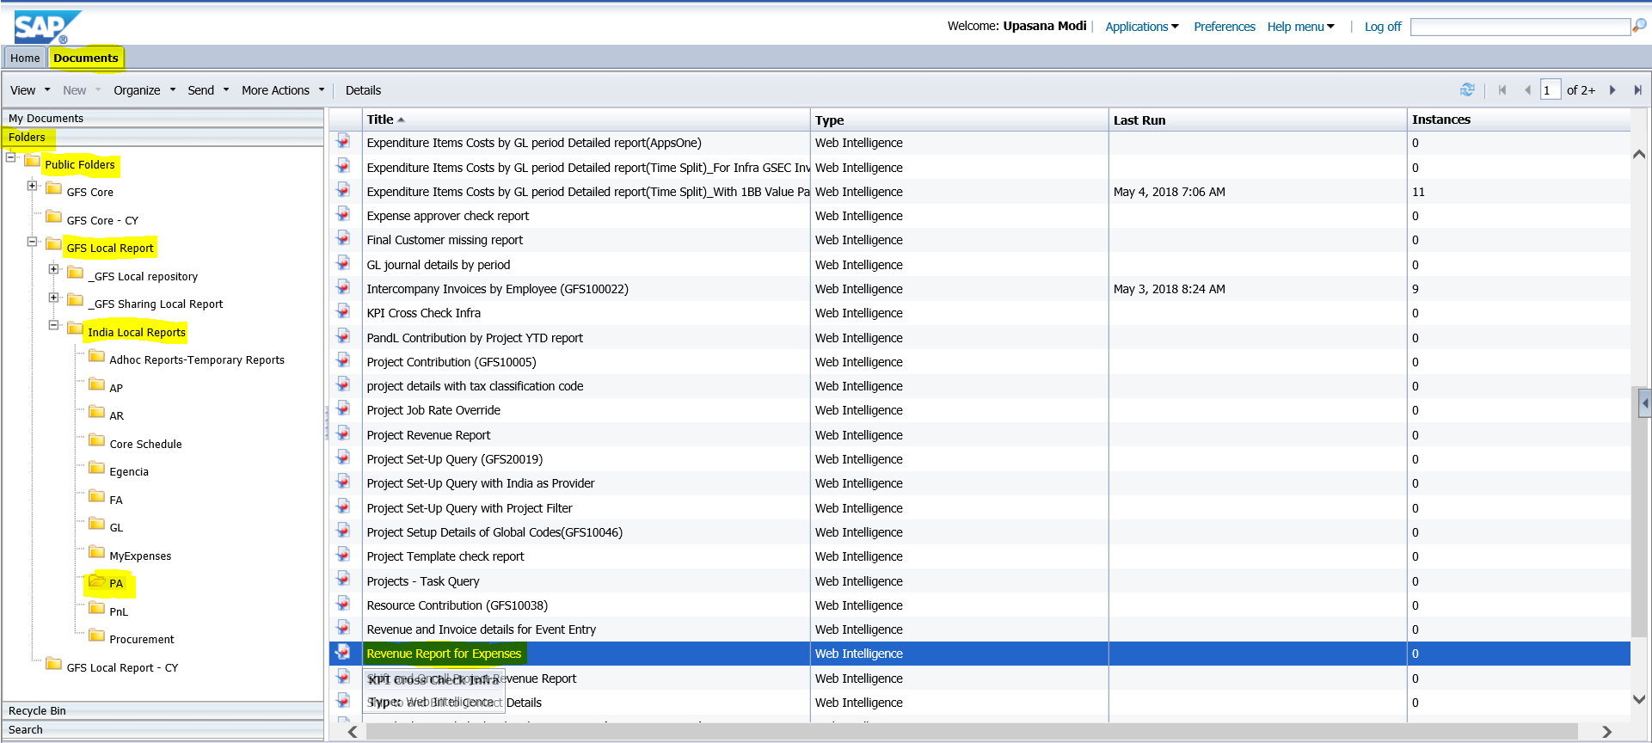

* Click on the Refresh button  as below:-

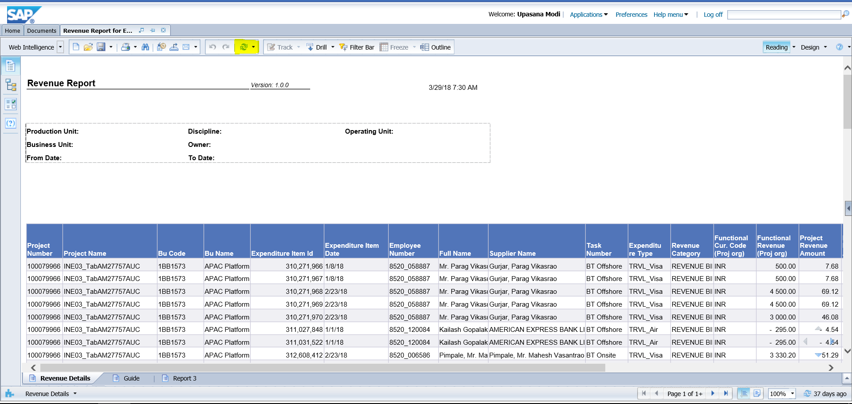

* A dialogue box will appear as below:

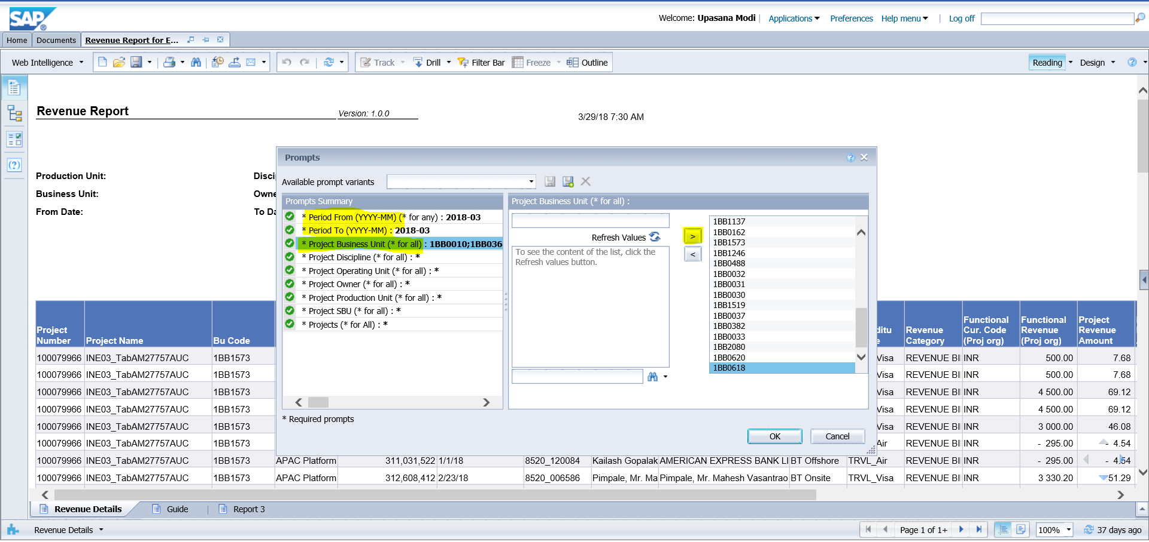

**Prompts to be entered:**

* **Period From (YYYY-MM)-enter the previous month**
* **Period To (YYYY-MM)-enter the previous month**
* **For Project business unit (*for all) - go to** **file:///\\ntbomfs001\Datagrp\FINANCE%20MODULE\Finance%202018\Global%20Shared%20Services\Invoicing%20Tower\Others\BU%20Code%20List_GSS_2018.xlsx**
* **After opening “BU Code List_GSS_2018” go to C52 of Formula sheet. Copy and paste the list as per below example. And click on the arrow as shown in example.**(If there are values in the right most box then double click on it then enter the BU list in the text box and click on side arrow)
* **Revenue GL month- enter the previous month**

(If there are values in the right most box then double click on it then enter the previous month in the text box and click on side arrow)

* Click on OK
* Once the data is retrieved, Click on Export button 
* Go to file type dropdown and Select Excel(.xlsx) & click OK ( as shown below)

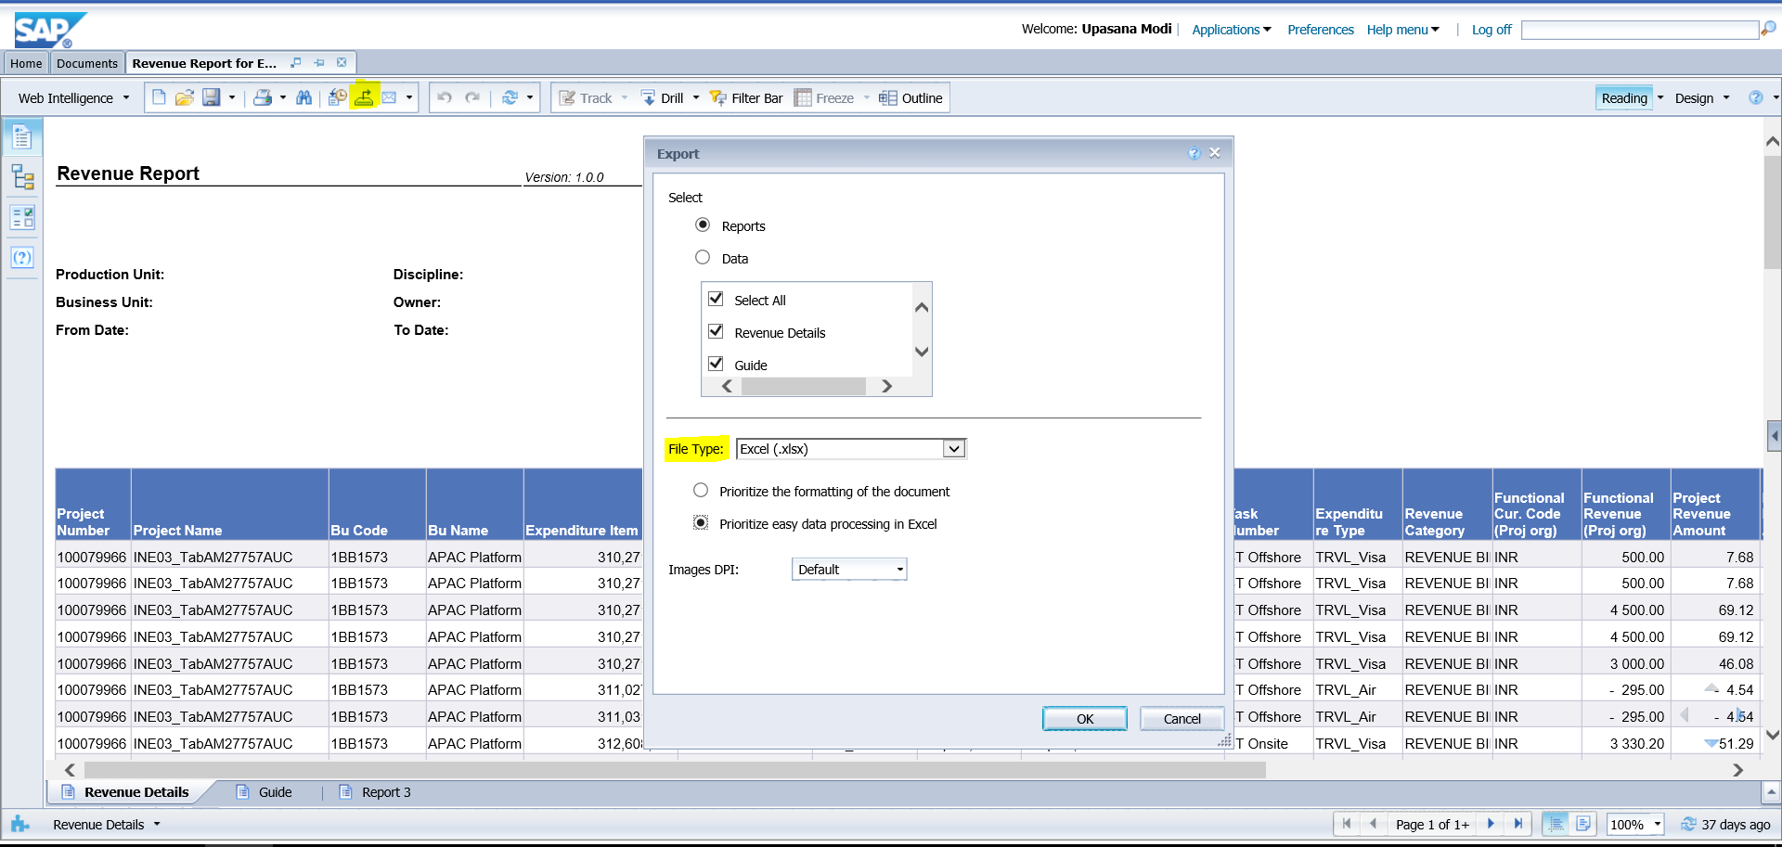

* Another dialogue box will appear as below:-



* Click on the arrow next to Save and select Save As.
* Save the file in the respective folder of current month’s repository.
  1. Extraction of Shift and Oncall Project Revenue Report from BI Tool

Login to BI tool <http://gfsbi4.capgemini.com/BOE/BI>

Enter Login ID Password

Go to Documents tab 🡪 Folders 🡪 Public Folders 🡪 GFS Local Report 🡪 India Local Report 🡪PA 🡪 Shift and Oncall Project Revenue Report

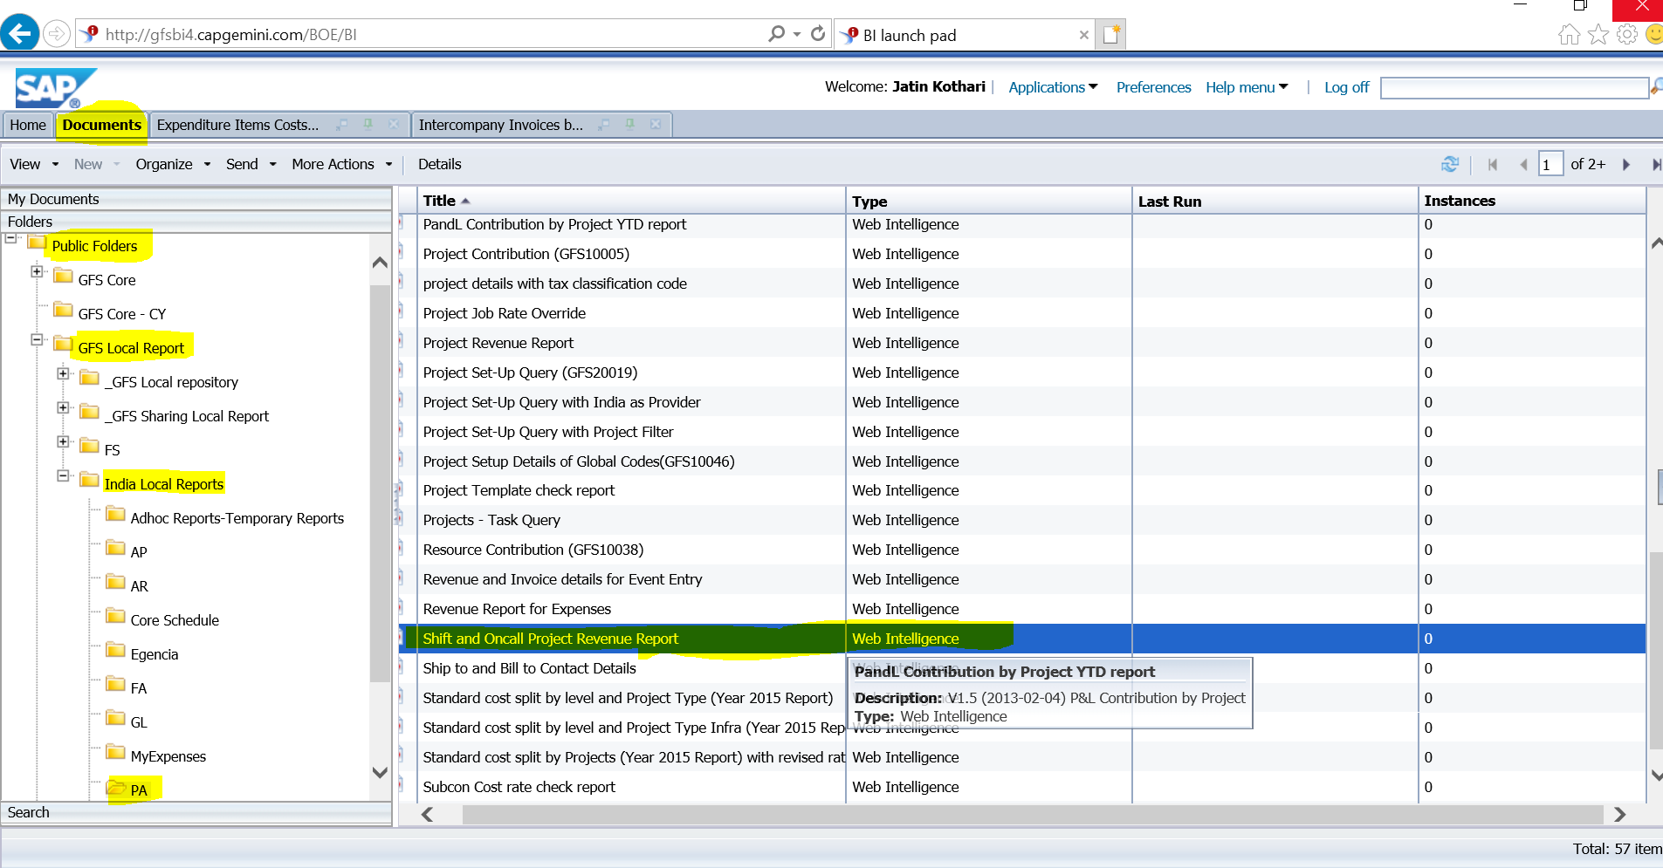

* Click on the Refresh button as below:-

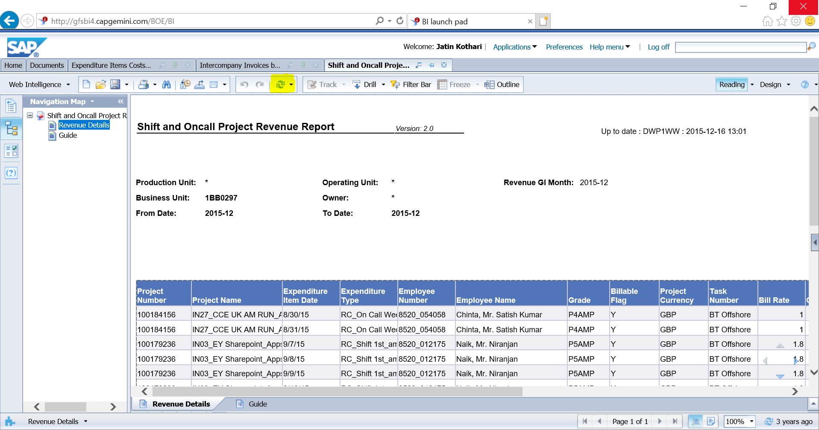

* A dialogue box will appear as below:



* **Prompts:**
* **Period From (YYYY-MM)-enter the previous month**
* **Period To (YYYY-MM)-enter the previous month**
* **For Project business unit (*for all)- go to** **file:///\\ntbomfs001\Datagrp\FINANCE%20MODULE\Finance%202018\Global%20Shared%20Services\Invoicing%20Tower\Others\BU%20Code%20List_GSS_2018.xlsx**
* **After opening “BU Code List_GSS_2018” go to C52 of formula sheet. Copy and paste the list as per below example. And click on the arrow as shown in example.**(If there are values in the right most box then double click on it then enter the BU list in the text box and click on side arrow)
* **Revenue GL month- enter the previous month.**(If there are values in the right most box then double click on it then enter the previous month in the text box and click on side arrow)
* Click on OK
* Once the data is retrieved, Click on Export button à Go to file type dropdown ànd  Select Excel(.xlsx) & click OK

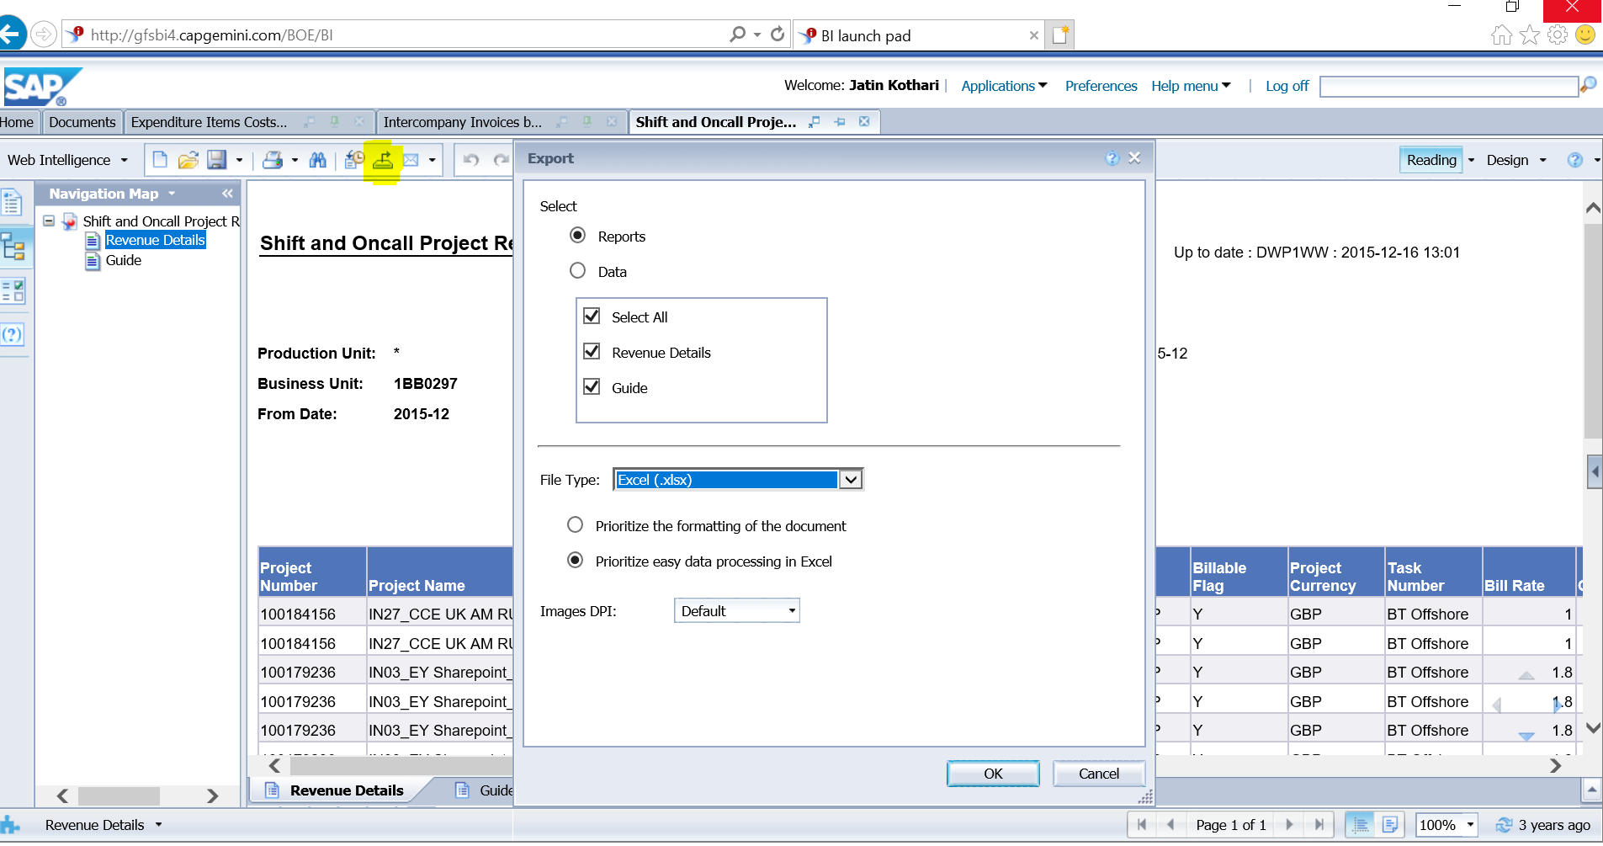

* Another dialogue box will appear as below:-



* Click on the arrow next to Save and select Save As.
* Save the file in the respective folder of current month’s repository and start the working.
  1. Extraction of Project Set-Up Query from BI Tool
* Login to BI tool <http://gfsbi4.capgemini.com/BOE/BI>
* Enter Login ID Password
* Then refer the report which is in the inbox (go to documents 🡪Inbox)
* Click on the refresh button.

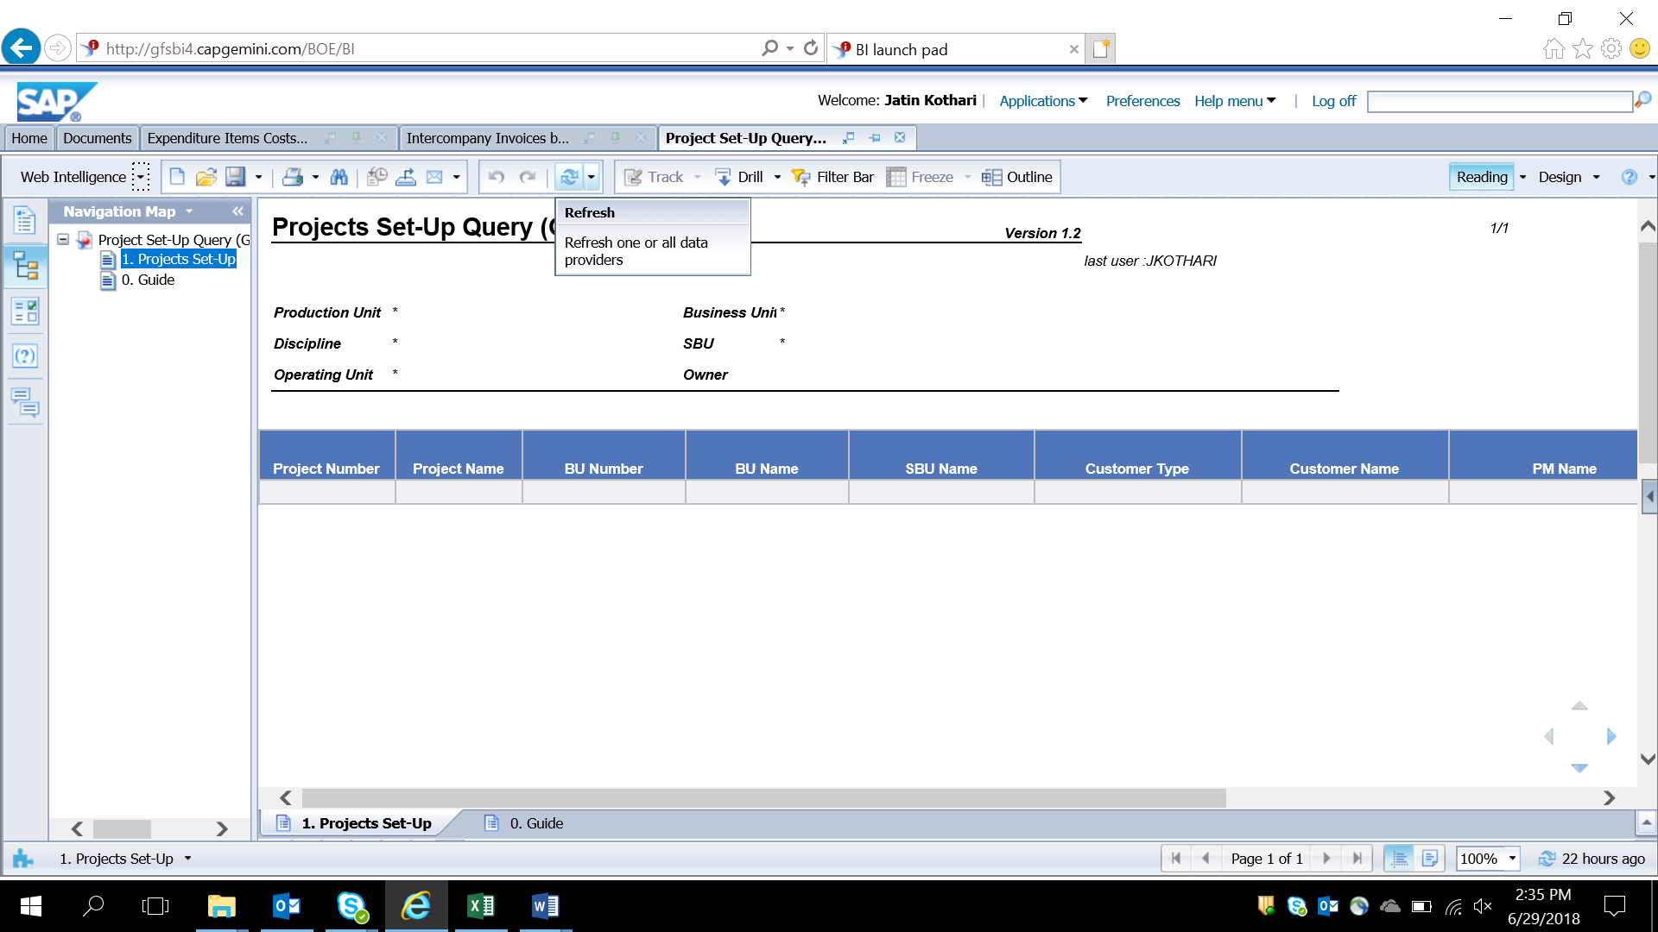

* Enter the below Prompts given:
* **Project Business unit** : Go to **file:///\\ntbomfs001\Datagrp\FINANCE%20MODULE\Finance%202018\Global%20Shared%20Services\Invoicing%20Tower\Others\BU%20Code%20List_GSS_2018.xlsx**
* After opening “BU Code List_GSS_2018” go to C52 of formula sheet. Copy and paste the list in BI Tool (Project Business Unit) as per above example. And click on the arrow as shown in the example.(If there are values in the right most box then double click on it then enter the BU list in the text box and click on side arrow)
* Role type 1: Project controller
* Role type 2 : Program Manager
* Click on OK
* Once the report is extracted, click on export option.

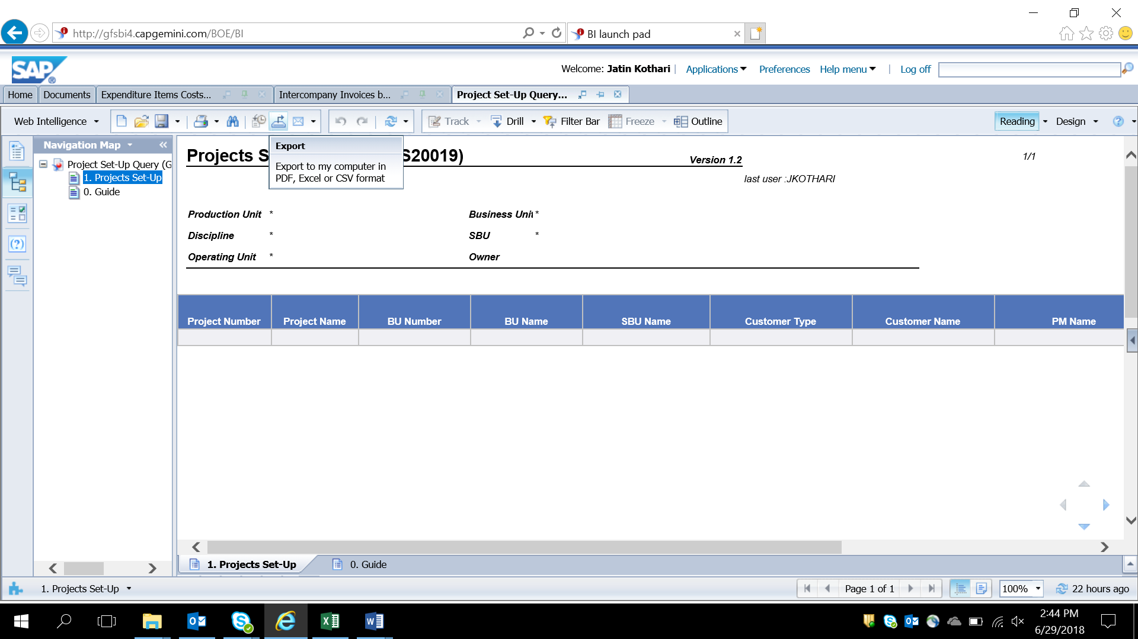

* Go to file type dropdown 🡪 Select Excel(.xlsx) & click OK
* A dialogue box will appear as below :-
* 
* Click the drop down besides save & select Save as
* Save the file in the respective folder of current months repository

1. Workings
   1. Workings in the PCR Template

* Go to the respective repository and open the file of Project Contribution Report extracted from the BI Tool (System Dump).
* Go to cell A14 Type Ctrl ↓ (Down arrow) & Delete all the rows where the cells are empty
* Go to \\ntbomfs001\DATAGRP\FINANCE MODULE\Finance 2018\Global Shared Services\Invoicing Tower\Others\Templates
* Open the Template for PCR
* Click on Enable Content in the yellow line appeared below the ribbon tab.
* Copy the columns of Project Contribution report starting from A15:C15 till the last cell of the columns having value and paste it in the Template’s A15:C15 column of PCR mmm’yy sheet
* Copy the columns of Project Contribution report starting from E15:F15 till the last cell of the columns having value and paste it in the Template’s E15:F15 column of PCR mmm’yy sheet
* Copy the columns of Project Contribution report starting from G15:AW15 till the last cell of the columns having value and paste it in the Template’s H15:AX15 column of PCR mmm’yy sheet
* Close the Project Contribution Report
* Open the PCR Supporting template
* Click on cell E8 of PCR template, Press (Ctrl +Shift +↓), Convert it into Text to Column ( Alt + A + E).
* Open the Project Revenue Report, Go to Cell B12. Press (Ctrl + Shift + ↓)
* Convert it into Text to Column ( Alt + A + E) , then Copy the data ( Ctrl + C) & Paste it (Alt + E + S + V) in PCR Supporting Template in cell A2 of PRR sheet.
* Go to the Project Revenue Report, Go to Cell O12. Press (Ctrl + Shift + ↓)
* Copy the data ( Ctrl + C) & Paste it (Alt + E + S + V) in PCR Supporting Template in cell B2 of PRR sheet.
* Open the Revenue Report for Expense, Go to Cell B12. Press (Ctrl + Shift + ↓)
* Convert it into Text to Column ( Alt + A + E) , then Copy the data ( Ctrl + C) & Paste it (Alt + E + S + V) in PCR Supporting Template in cell A2 of PRE sheet.
* Go to the Revenue Report for Expense, Go to Cell Q12. Press (Ctrl + Shift + ↓)
* Copy the data ( Ctrl + C) & Paste it (Alt + E + S + V) in PCR Supporting Template in cell B2 of PRE sheet.
* Open the Shift On Call Project Revenue Report , Go to Cell B12. Press (Ctrl + Shift + ↓)
* Convert it into Text to Column ( Alt + A + E) , then Copy the data ( Ctrl + C) & Paste it (Alt + E + S + V) in PCR Supporting Template in cell A2 of SOC sheet.
* Go to the Shift On Call Project Revenue Report, Go to Cell Q12. Press (Ctrl + Shift + ↓)
* Copy the data ( Ctrl + C) & Paste it (Alt + E + S + V) in PCR Supporting Template in cell B2 of SOC sheet.
* Open the Revenue and Invoice details for Event Entry Report, Go to Cell B5. Press (Ctrl + Shift + ↓)
* Convert it into Text to Column ( Alt + A + E) , then Copy the data ( Ctrl + C) & Paste it (Alt + E + S + V) in PCR Supporting Template in cell A2 of Event Entry sheet.
* Go to the Revenue and Invoice details for Event Entry Report, Go to Cell G5. Press (Ctrl + Shift + ↓)
* Copy the data ( Ctrl + C) & Paste it (Alt + E + S + V) in PCR Supporting Template in cell B2 of Event Entry sheet.
* Go to the Revenue and Invoice details for Event Entry Report, Select Cells I5:J5. Press (Ctrl + Shift + ↓)
* Copy the data ( Ctrl + C) & Paste it (Alt + E + S + V) in PCR Supporting Template in cell C2 of Event Entry sheet.
* Open the Project Set-Up Query Report, Go to Cell A14. Press (Ctrl + Shift + ↓)
* Convert it into Text to Column ( Alt + A + E) , then Copy the data ( Ctrl + C) & Paste it (Alt + E + S + V) in PCR Supporting Template in cell A2 of PSQ Sheet.
* Go to the Project Set-Up Query Report, select Cells from B14 to D14. Press (Ctrl + Shift + ↓)
* Copy the data ( Ctrl + C) & Paste it (Alt + E + S + V) in PCR Supporting Template in cell B2 of PSQ Sheet.
* Go to the Project Set-Up Query Report, select cells F14 to G14. Press (Ctrl + Shift + ↓)
* Copy the data ( Ctrl + C) & Paste it (Alt + E + S + V) in PCR Supporting Template in cell E2 of PSQ Sheet.
* Go to the Project Set-Up Query Report, Go to Cell J14. Press (Ctrl + Shift + ↓)
* Copy the data ( Ctrl + C) & Paste it (Alt + E + S + V) in PCR Supporting Template in cell G2 of PSQ Sheet.
* Go to the Project Set-Up Query Report, select cells from L14 to N14. Press (Ctrl + Shift + ↓)
* Copy the data ( Ctrl + C) & Paste it (Alt + E + S + V) in PCR Supporting Template in cell H2 of PSQ Sheet.
* Go to Data Tab, Click on Refresh All
* Go to PCR Template.
* Click on cell AZ, Go to the formula box, copy the data then go to AZ8, type = and paste (Ctrl + V)
* Similarly, do the same procedure for columns BA to BE, BG to BL, BN to BS, BU, BV, BZ to CD, CF to CI.
* To break links Press (Alt + A + K), a dialogue box will appear, click on Break links,then click break, then close the dialogue box.
* Go to cell D14 🡪 click on the dropdown arrow 🡪 unselect internal 🡪 Go to cell A15 🡪 press ( Shift + Ctrl + →) till you reach cell C15 🡪 press ( Shift + Ctrl + ↓ ) 🡪 Cut the data ( Ctrl + X) 🡪 Go to External sheet, cell A2 , and paste the data ( Ctrl + V) 🡪 Go to PCR sheet, cell D14 , click on the dropdown button and select Internal.
* Go to pivot sheet 🡪 Data Tab 🡪 click on Refresh All
* Go to PCR sheet 🡪 Go to cell CI14 🡪 Click on the drop down 🡪 Unselect the value of 0 , 0.00,(0.00).
* If there is difference in any project code, a mail has to be sent to the respective invoicing spocs to extract the fresh data from BI Tool & check/analyse the differences
* For email ID of invoicing spocs refer to the Ref sheet in the PCR template.
* Save the PCR template and PCR Suporting in the current month’s repository.
  1. Project Revenue Report

1. **Working :**

* Once the system report is opened,
* Select the entire column B from B12 to the last raw of the report, Press Alt A+E to convert it into text to column.
* Then Open the template from the below path
  + \\ntbomfs001\DATAGRP\FINANCE MODULE\Finance 2018\Global Shared Services\Invoicing Tower\Others\Templates
* Click on Enable Content in the yellow line appeared below the ribbon tab.
* Copy the report (Ctrl + C) from B12 to M12 till the last row of the report.
* Paste it in the template (Alt + E+S+V) from A4 to L4.
* Copy the report (Ctrl + C) from O12 to R12 till the last row of the report.
* Paste it in the template (Alt + E+S+V) from M4 to P4.
* In the template, go to O column, filter the customer name column with Sogeti USA LLC, CAPGEMINI AUSTRALIA PTY LTD, CAPGEMINI (CHINA) CO LTD, delete those rows by using shift + space bar(selecting the rows ) and then (Ctrl –)
* Drag the formula from Q4 to T4 till the last value in the column. ( Change the Month in the description column to Previous month)
* Go to ICB/NON ICB column 🡪 Click on the Drop down 🡪 Unselect NON ICB 🡪delete the lines with ICB by pressing (Ctrl +↓) , (Shift + Space) then ( Ctrl -) & Press (Alt+A+C)
* Go to Customer Type column 🡪 Go to row 1🡪 copy the text from formula tab and paste it in the 4th row after typing (=)
* Click on the Drop down of customer type title 🡪 Unselect Internal 🡪delete the lines with External by pressing (Ctrl + Shift + ↓) , (Shift + Space) then ( Ctrl -) & Press (Alt+A+C)
* Go to supporting Pivo, refresh the pivo by going to Analyze (tab) 🡪 click on Refresh
* Go to Analyze tab 🡪 Options🡪show report filter pages🡪 click on Description🡪click on OK
* Go to the button of Split Drafts in Ref sheet in the template and click on it.
* A dialogue box will appear in that enter the path to save the sheets.

Path –

* Enter the current months repository for supportings.

1. **Project revenue report for China :**
2. **Workings:-**

* Open the system report for Project Revenue
* Select the entire column B from B12 till the last cell having value in it. Press Alt + A+E to convert it into text to column.
* Then Open the template from the below path
  + <file:///\\ntbomfs001\Datagrp\FINANCE%20MODULE\Finance%202018\Global%20Shared%20Services\Invoicing%20Tower\Others\Templates\1.Project%20Revenue%20Report_Template_China.xlsx>
* Click on Enable Content in the yellow line appeared below the ribbon tab.
* Copy the report (Ctrl + C) from B12 to M12 till the last row of the report.
* Paste it in the template (Alt + E+S+V) from A4 to L4.
* Copy the report (Ctrl + C) from O12 to R12 till the last row of the report.
* Paste it in the template (Alt + E+S+V) from M4 to P4.
* In the template, go to O column, filter the customer name column, delete all rows **except** CAPGEMINI (CHINA) CO LTD by using shift+ space bar(selecting the rows ) and then (Ctrl –)
* Drag the formula from Q4 to T4 till the last value in the column. ( Change the Month in the description column to Previous month)
* Go to supporting Pivo, refresh the pivo by going to Analyze (tab) 🡪 click on Refresh
* Go to Analyze tab 🡪 Options🡪show report filter pages🡪 click on Description🡪click on OK
* Go to the button of Split Drafts of Ref sheet in the template and click on it.
* A dialogue box will appear in that enter the path to save the sheets.

Path—

* Enter the current months repository for supportings.
  1. Expenses

**b) Workings of Expenses in the Template**

* Open the extracted revenue report for expenses extracted from the respective repository
* Go to row 11 and select the entire row (Shift+ Space bar),(Ctrl + Shift +↓) then remove merging ( Alt + H+M+C)
* Delete entire column D & I (Ctrl -)
* Select the entire column B from B12 till the last cell having value in it. Press (Alt + A+E) to convert it into text to column.
* Then Open the template from the below path -
  + \\ntbomfs001\DATAGRP\FINANCE MODULE\Finance 2018\Global Shared Services\Invoicing Tower\Others\Templates
* Click on Enable Content in the yellow line appeared below the ribbon tab.
* Copy the entire report from B12 to Y12 till the last row of the report/data.
* Paste it in the template from A4 to V4
* In the template, go to U column, filter the customer name column with Sogeti USA LLC & Capgemini Consulting Österreich AG (AUSTRIA), CAPGEMINI (CHINA) CO LTD & Delete those rows by using shift+ space bar(selecting the rows ) and then Ctrl + (–)
* Drag the formula from W4:T4 till the last value in the column. ( Change the Month in the description column to Previous month)
* Go to ICB/NON ICB column 🡪 Click on the Drop down 🡪 Unselect NON ICB 🡪delete the lines with ICB by pressing (Ctrl +↓) , (Shift + Space) then ( Ctrl -) & Press (Alt+A+C)
* Go to Customer Type column 🡪 Go to row 1🡪 copy the text from formula tab and paste it in the 4th row after typing (=)
* Click on the Drop down of customer type title 🡪 Unselect Internal 🡪delete the lines with External by pressing (Ctrl + Shift + ↓) , (Shift + Space) then ( Ctrl -) & Press (Alt+A+C)
* Go to Supporting Pivo sheet 🡪 Data (tab) 🡪 click on Refresh All
* Go to Analyze tab 🡪 Options🡪show report filter pages🡪 click on Description🡪click on OK
* Go to the button of Split Drafts of Entity_ICB Details sheet in the template and click on it.
* A dialogue box will appear in that enter the path to save the sheets.

Path—

* Enter the current months repository for supportings.

1. **Expense report for China**
2. **Workings**

* Open the extracted revenue report for expenses extracted from the respective repository
* Go to row 11 and select the entire row (Shift+ Space bar), (Ctrl + ↓) then remove merging ( Alt + H+M+C)
* Delete entire column D&I (Ctrl -)
* Select the entire column B from B12 till the last cell having value in it. Press (Alt + A+E) to convert it into text to column.
* Then Open the template from the below path

\\ntbomfs001\DATAGRP\FINANCE MODULE\Finance 2018\Global Shared Services\Invoicing Tower\Others\Templates

* Click on Enable Content in the yellow line appeared below the ribbon tab.
* Copy the entire report from B12 to Y12 till the last row of the report/data.
* Paste it in the template from A4 to V4
* In the template, go to O column, filter the customer name column, delete all rows **except** CAPGEMINI (CHINA) CO LTD by using shift+ space bar(selecting the rows ) and then (Ctrl –)
* Drag the formula from W4:Y4 till the last value in the column. ( Change the Month in the description column to Previous month)
* Go to Supporting Pivo sheet 🡪 Data (tab) 🡪 click on Refresh All
* Go to Analyze tab 🡪 Options🡪show report filter pages🡪 click on Description🡪click on OK
* Go to the button of Split Drafts of Entity_ICB Details sheet in the template and click on it.
* A dialogue box will appear in that enter the path to save the sheets.

Path—

* Enter the current months repository for supportings.
  1. Shift On Call

1. **Working:**

* Once the system report is opened, Go to row 11 and select the entire row , (Shift+ Space bar), (Ctrl + ↓), then remove merging ( Alt + H+M+C)
* Delete entire column N (Ctrl -)
* Select the entire column B from B12 till the last cell having value in it. Press (Alt+A+E) to convert it into text to column.
* Then Open the template from the below path

<file:///\\ntbomfs001\Datagrp\FINANCE%20MODULE\Finance%202018\Global%20Shared%20Services\Invoicing%20Tower\Others\Templates\SOC_Template.xlsx>

* Click on Enable Content in the yellow line appeared below the ribbon tab.
* Copy the entire report (Ctrl + C) from B12 to R12 till the last row of the report.
* Paste it in the template(Alt + E+S+V) from A2 to Q2
* In the template, go to O column, filter the customer name column with Sogeti USA LLC, CAPGEMINI AUSTRALIA PTY LTD, delete those rows by using shift+ space bar(selecting the rows ) and then (Ctrl –)
* Drag the formula from R2 to V2 till the last value in the column. ( Change the Month in the description column to Previous month)
* Go to ICB/NON ICB column 🡪 Click on the Drop down 🡪 Unselect NON ICB 🡪delete the lines with ICB by pressing (Ctrl +↓) , (Shift + Space) then ( Ctrl -) & Press (Alt+A+C)
* Go to Customer Type column 🡪 Go to row 1🡪 copy the text from formula tab and paste it in the 4th row after typing (=)
* Click on the Drop down of customer type title 🡪 Unselect Internal 🡪delete the lines with External by pressing (Ctrl + Shift + ↓) , (Shift + Space) then ( Ctrl -) & Press (Alt+A+C)
* Go to supporting Pivo, refresh the pivo by going to Analyze (tab) 🡪 click on Refresh
* Go to Analyze tab 🡪 Options🡪show report filter pages🡪 click on Description🡪click on OK
* Go to the button of Split Drafts of Ref sheet in the template and click on it.
* A dialogue box will appear in that enter the path to save the sheets.

Path—

* Enter the current months repository for supportings.
  1. Working of Invoice Tracker
* Open the PCR Supporting file for the month ( which is already prepared for PCR working)
* Open the Invoicing Tracker template for the templates folder
* (Save As) Press F12 🡪 Invoice tracker_MMM’YY (Previous Month)
* Go to PRR Pivo sheet in the PCR supporting file.
* Go to cell A4 🡪 (Ctrl + Shift + ↓) 🡪 (Shift + ↑) 🡪Copy (Ctrl + C) 🡪 Go to cell D4 of Invoice tracker 🡪 Paste (Ctrl + Alt + V + V) Click on OK.
* Go to PRR Pivo sheet in the PCR supporting file.
* Go to cell B4 🡪 (Ctrl + Shift + ↓) 🡪 (Shift + ↑) 🡪Copy (Ctrl + C) 🡪 Go to cell M4 of Invoice tracker 🡪 Paste (Ctrl + Alt + V + V) Click on OK.
* Go to Cell C1 of PRR Pivo sheet in PCR supporting file 🡪 Copy from formula box 🡪 Go to cell C4 🡪 type ( = ) then Paste (Ctrl +V) & change the month to previous month 🡪 Click ( ← ) then (Ctrl + ↓) then click (→ + ↑) then press (Ctrl + Shift + ↑) 🡪 press (Ctrl + D) 🡪 Copy (Ctrl + C) 🡪 Go to cell Q4 of Invoice tracker 🡪 Paste (Ctrl + Alt + V + V) Click on OK.
* Go to PRE Pivo sheet in the PCR supporting file.
* Go to cell A4 🡪 (Ctrl + Shift + ↓) 🡪 (Shift + ↑) 🡪Copy (Ctrl + C) 🡪 Go to cell D4 of Invoice tracker 🡪 Press (Ctrl + ↓) then (↓) 🡪 Paste (Ctrl + Alt + V + V) Click on OK.
* Go to PRE Pivo sheet in the PCR supporting file.
* Go to cell B4 🡪 (Ctrl + Shift + ↓) 🡪 (Shift + ↑) 🡪Copy (Ctrl + C) 🡪 Go to cell N4 of Invoice tracker 🡪 Press (Ctrl + ↓) then (↓) 🡪 Paste (Ctrl + Alt + V + V) Click on OK.
* Go to Cell C1 of PRE Pivo sheet in PCR supporting file 🡪 Copy from formula box 🡪 Go to cell C4 🡪 type ( = ) then Paste (Ctrl +V) & change the month to previous month 🡪 Click ( ← ) then (Ctrl + ↓) then click (→ + ↑) then press (Ctrl + Shift + ↑) 🡪 press (Ctrl + D) 🡪 Copy (Ctrl + C) 🡪 Go to cell Q4 of Invoice tracker 🡪 Press (Ctrl + ↓) then (↓) 🡪 Paste (Ctrl + Alt + V + V) Click on OK.
* Go to SOC Pivo sheet in the PCR supporting file.
* Go to cell A4 🡪 (Ctrl + Shift + ↓) 🡪 (Shift + ↑) 🡪Copy (Ctrl + C) 🡪 Go to cell D4 of Invoice tracker 🡪 Press (Ctrl + ↓) then (↓) 🡪 Paste (Ctrl + Alt + V + V) Click on OK.
* Go to PRE Pivo sheet in the PCR supporting file.
* Go to cell B4 🡪 (Ctrl + Shift + ↓) 🡪 (Shift + ↑) 🡪Copy (Ctrl + C) 🡪 Go to cell M4 of Invoice tracker 🡪 Press (Ctrl + ↓) then (↓) 🡪 Paste (Ctrl + Alt + V + V) Click on OK.
* Go to Cell C1 of PRE Pivo sheet in PCR supporting file 🡪 Copy from formula box 🡪 Go to cell C4 🡪 type ( = ) then Paste (Ctrl +V) & change the month to previous month 🡪 Click ( ← ) then (Ctrl + ↓) then click (→ + ↑) then press (Ctrl + Shift + ↑) 🡪 press (Ctrl + D) 🡪 Copy (Ctrl + C) 🡪 Go to cell Q4 of Invoice tracker 🡪 Press (Ctrl + ↓) then (↓) 🡪 Paste (Ctrl + Alt + V + V) Click on OK.
* Go to invoice template 🡪 Go to A1 🡪 copy the formula from the formula tab (Ctrl +C)🡪 Go to A7 🡪 type (=) and Paste (Ctrl + V) 🡪 Drag the formula till the last cell of the data.
* Repeat the process for the columns B,E,P,S,T,W,AF,AH,AI. 🡪 Press (Alt + A + K ) 🡪 Click on Break link then Close
* Filter customer China and enter the currency in column F as USD , for the rest of the customers enter the currency as INR
* Save the file Press (Ctrl + S)
* Press F12 🡪 Edit the name of the file to Invoices Shared to PM
* Go to cell B6 🡪 select the dropdown 🡪 unselect Internal 🡪 click on down arrow and go to the cell downwards 🡪 Press (Ctrl + Shift + ↓) 🡪 Press ( Shift + space) 🡪

Press ( Alt + ;) 🡪 Press ( Ctrl - ) 🡪 Go to Cell B6 and select Internal.

* Go to Cell AI6 🡪 unselect Non ICB 🡪 click on down arrow and go to the cell downwards 🡪 Press (Ctrl + Shift + ↓) 🡪 Press ( Shift + space) 🡪 Press ( Alt + ;) 🡪 Press ( Ctrl - ) 🡪 Go to cell AI6 and select Non ICB.
* Go to Data tab and click on Refresh All
* Press (Ctrl + S)
* Go to Pivo Sheet 🡪 select the PM ID’s one by one 🡪 pull out the respective supportings file of the project code under that PM (from the supporting folder) 🡪 attach that in the draft mail of approval to be sent to PM. Fill data in the columns D & E of Pivo sheet.
* After sending the drafts save the file ( Ctrl + S )